Project Report: Design of an Automated Conveyor Belt System
Student Name: Mitushi Jain
Internship Domain: Robotics & Automation
Date: June 12, 2026
1. Project Overview
The objective of this project is to design a logic-based conveyor system that automates the material handling process. In traditional manufacturing, manual transport of goods is prone to human error and inefficiency. This design utilizes a microcontroller-based architecture to detect, transport, and sort objects, thereby increasing throughput and consistency in a production environment.
2. System Architecture
The system is built on a modular design comprising four key subsystems:
- Sensing Module: Utilizes Infrared (IR) or Ultrasonic sensors to detect the presence of an object at the input and output stages of the conveyor.
- Control Module: A microcontroller (e.g., Arduino or PLC) acts as the brain, processing sensor inputs and executing control logic.
- Actuation Module: A DC motor and a relay module drive the conveyor belt. The relay acts as an electronic switch, allowing the low-power microcontroller to safely control the high-power motor.
- Power Management: A stabilized power supply ensures consistent voltage to both the control logic and the drive motors.
3. Working Principle
The system follows a continuous loop logic:
- Detection: When an object is placed at the start of the conveyor, the Input Sensor detects the obstruction and sends a "High" signal to the microcontroller.
- Actuation: The microcontroller processes this signal and triggers the Relay Module, which completes the circuit for the DC Motor.
- Transport: The conveyor belt moves the object across the track at a constant velocity.
- Completion: Upon reaching the end of the conveyor, the Exit Sensor detects the object, prompting the microcontroller to cut power to the Relay.
- Sorting/Packaging: The stopping of the belt allows a secondary mechanism (like a pneumatic pusher or robotic arm) to sort or package the object, after which the system resets for the next cycle.
4. Design Logic (Flowchart)
Refer to the attached Flowchart diagram. The logic flow ensures that the system is "event-driven"—meaning it only consumes energy when an object is actively being moved, optimizing the overall power efficiency of the facility.

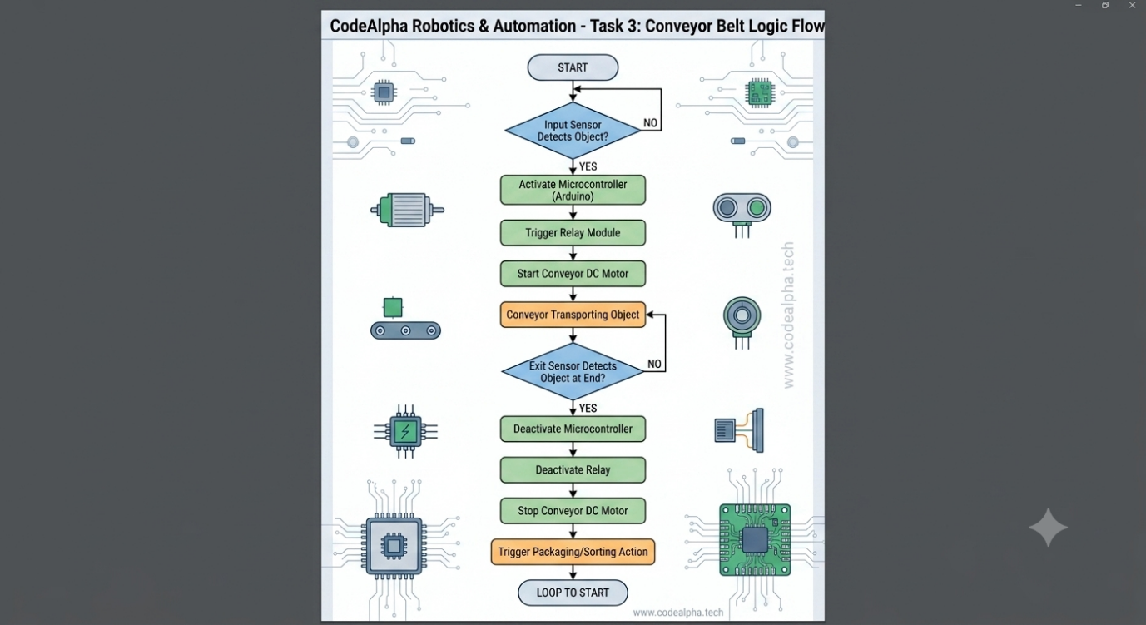
5. Applications and Benefits
- Applications: This system is highly scalable for use in food packaging, electronics assembly lines, and warehouse logistics.
- Scalability: The design can be expanded by adding more sensors for real-time tracking or by integrating IoT modules to monitor belt performance remotely.
- Operational Benefits:
  - Reduced Labor Costs: Eliminates the need for manual transport.
  - Consistent Throughput: Maintains a steady pace that human workers cannot sustain over long periods.
  - Error Reduction: Automated detection ensures that objects are spaced correctly, preventing jams and collisions.
6. Conclusion
The automated conveyor belt system is a fundamental building block of modern industrial automation. By combining low-cost sensors with robust control logic, this system demonstrates how basic robotics can solve complex industrial bottlenecks. This design provides a foundation for more advanced smart-factory implementations.

